AULTMAN HEALTH
I93 Aultman Vendor Import
Inbound Interface (New Vendor Request -> FSM)

Document Properties
Author | Paolo Enrico Vicente, Daryll Blu Papellero
Creation Date | 10/11/2023
Last Updated | 12/01/2023
Document Reference | ANA-050 + DES-020
Version | 1.1

Document Control

Change Record
1
Date | Author | Version | Change Reference
10/11/2023 | Paolo Enrico Vicente | 1.0 | Initial draft: Executive Summary, Functional Specification, Testing Process
12./01/2023 | April Hope Remandaban | 1.1 | Additions (Inclusion of Vendor Location): Executive Summary, Business Objectives, Assumptions, Functional Specification, Business Process Flow, Field Mapping
MM/dd/yyyy | <Functional Resource> | 1.1
MM/dd/yyyy
MM/dd/yyyy

Contents
1 Document Control 2
1.1 Change Record 2
2 Executive Summary 4
2.1 Business Objectives 4
2.2 Assumptions 4
3 Functional Specifications 5
3.1 Overview 5
3.2 Functional Requirements 5
3.3 Business Process Flow 8
3.4 Field Mapping 9
4 Technical Specifications 13
4.1 Solution Overview 13
4.2 Technical Configurations 13
5 Testing Process 22
6 Signature 24
6.1 Functional Specification 24
6.2 Technical Specification 24
7 Appendix 25
7.1 Client Approval 25
7.2 Sample Vendor Files 25
7.3 LPL Codes 25
7.4 Process Flow 25

Executive Summary
Aultman Health Foundation (AHF) has an Internal source system that is used to create New Vendor for NON PO that are being sent daily to the Aultman AP team.
This document describes the functional requirements to upload the Non PO New Vendors from Aultman’s Internal application to the Vendor Import Interface of the Infor Cloudsuite Financials (FSM).

Business Objectives
This interface intends to change the process by picking up the Request New Vendor file from the Internal application and load it into the Vendor business class of the Infor Cloudsuite Financial via VendorImport business class. This is only applicable for those vendor records with TRADE VENDORS vendor class.

Assumptions
This specification assumes that the following statements are true. Any changes can result in a change order and will be managed using the change order process as defined in the Service Workorder.
- The interface file generated by the provider is in FSM acceptable format ready and will be used to update Vendor Records in Cloudsuite Financials.
- Validation will not be performed during the file import process, rather, the data validation will take place after the record has been imported.
- File naming convention will be provided by AHF for the source file.
- Source File will be sent daily and multiple times.
- UserField will be created to input Service Type. Name of the user field will be AHVendorServiceType
- Records that will be imported are only for TRADE VENDORS (TRD) vendor class.

Functional Specifications

Overview
The inbound interface will use Infor Cloudsuite Financials functionality to load New Non-PO vendors with TRD vendor class from Aultman’s Internal application to Infor CSF Global Ledger via VendorImport business class.

Functional Requirements

Functional Requirement ID | Requirement Definition
FR 1.1 | AHF needs a way to systematically pick up the new non-PO vendor records and upload it to FSM
FR 1.2 | AP Group identified by AHF needs to be notified when vendor records have been loaded successfully.
FR 1.3 | Interface Delivery Method
FR 1.4 | Input file will be converted to FSM format as needed
FR 1.5 | Error Handling
FR 1.6 | Archiving will be automated. Once the file has been processed, it will be move to the processed folder.

- File generated by internal application
File will be generated from Aultman’s Internal application, then load it to FSM Vendor Import Interface. The file will be modified to FSM upload format if needed.
- AP group to be notified
Group or Individual that will be notified for both successful and error run.

- interface delivery method
Interface Type | Inbound
Source System | Infor Financials and Supply Management (FSM)
Target System | Client FTP/SFTP location
Frequency | Daily Scheduled (8:30am and 2:30pm EST)
Trigger | File Channel
File Location | sftp.aultman.com
File Name | Vendors.csv
File Format | csv file
Input File Location to AHF SFTP | /CorporateFinance_Finance_FTPFiles/AP/NewVendorForm
Archive Input File Location to AHF SFTP | /CorporateFinance_Finance_FTPFiles/AP/NewVendorForm/Backup
Archive Output File Location to AHF SFTP
Archive File Name | Vendors.csv.YYYYMMDDhhmm

- MODIFICATION OF VENDOR FILE TO fsm format
IPA will automatically modify the new vendor request file to FSM format then upload it to FSM for import.
IPA will work on a batch of data coming from a single source file to be loaded to VendorImport business class. Records that are imported will only be for vendors under TRD Vendor Class.
Right after the first batch is loaded and saved, the Create Vendor Location Import action will automatically run and load to the business class. In the instance when no data from the source file related to vendor location are included, this won’t render the record invalid and will still be processed for interface.
Once all batches are loaded, the IPA will automatically run the Vendor Interface action to try to create permanent records in the Vendor business class.
Payables > Vendor Utilities > Vendor Interface
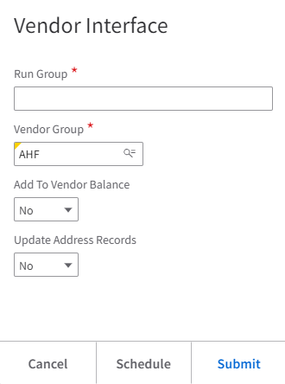
Vendor Group = AHF
*Parameters to use when running Interface

Results:
Payables > Vendor Utilities > Vendor Interfaces
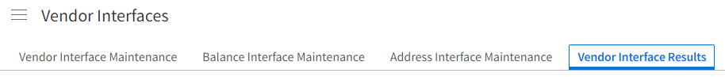

- Error handling
The IT support will be notified if any error has been encountered during processing.
To | BOSTeam@aultman.com
Cc | Amy.Nesmith@aultman.com
From | FSM_notification@infor.com
Subject | Vendor Import ERROR – NewVendorRequest_YYYYMMDDhhmm
Body Text | All Vendor Import records have error. Please check and determine the correction needed. Ensure the record in Cloudsuite is corrected. Re-run the interface after correction has been made.  No of Vendor Records with Error:  Technical details are as follows:  Run Group:  Date:  Work Unit:

successful data notification
The IT Support will be notified via email upon successful import.

To | Teresa.Bower@aultman.com
Cc | Amy.Nesmith@aultman.com
From | FSM_notification@infor.com
Subject | Vendor Import SUCCESSFUL – NewVendorRequest_YYYYMMDDhhmm
Body Text | All Vendor Import records have been imported to Vendor Business class successfully.  No of Vendor Records Created:  Run Group:  Date:  List of Vendors Created:  Sequence # Vendor ID Vendor Name  **1 45765 ATLANTIC ON CALL GROUP, LLC  **2 45766 MELANIE CRITES-BACHERT, LLC  Technical details are as follows:  Work Unit:  Process:  ** Sample data

PARTIALLY successful data notification
The IT Support will be notified via email upon successful import.

To | BOSTeam@aultman.com; Teresa.Bower@aultman.com
Cc | Amy.Nesmith@aultman.com
From | FSM_notification@infor.com
Subject | Vendor Import PARTIALLY SUCCESSFUL – NewVendorRequest_YYYYMMDDhhmm
Body Text | Vendor Import records have been imported to Vendor Business class partially.  No of Vendor Records Created:  No of Vendor Records with Error:  Run Group:  Date:  List of Vendors Created:  Sequence # Vendor ID Vendor Name  **1 45765 ATLANTIC ON CALL GROUP, LLC  **2 45766 MELANIE CRITES-BACHERT, LLC  Technical details are as follows:  Work Unit:  Process:  ** Sample data

- processed file to be archived
Processed files will automatically be moved to the processed folder.

Business Process Flow
Legend:
Process outside FSM / Manual process
IPA Driven

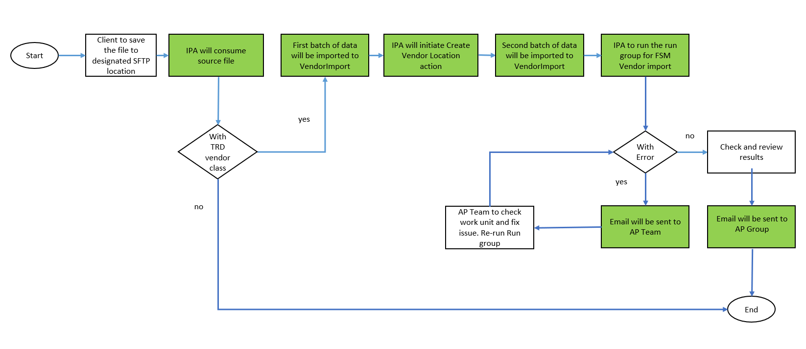

Field Mapping

Field Mapping for VENDOR interface

VendorImport
The target column can be used by the Vendor for the future state AP Vendor file being sent to AHF.
FIRST BATCH OF DATA TO BE LOADED
S No. | Target (VendorImport business class) | Input/source file | Remarks | Type | Size | Required
1 | VendorGroup | VendorGroup  (1) | HardCoded = “AHF” |  |  | Y
2 | VendorImport.Vendor |  | Blank (system generated)
3 | VendorImport.OldVendor | VendorName  (2) | Truncate to 20 |  | 20 | Y
4 | RunGroup |  | VENYYYYMMDDHHmm |  |  | Y
5 | NewVendor |  | Blank
6 | VendorClass | VendorClass  (3) | Include = TRD |  | 5 | Y
7 | VendorName | VendorName  (2) |  | ALPHALOWER | 120
8 | ContactName | ContactName  (13) |  | ALPHALOWER | 120
9 | VendorStatus |  | HardCoded = “A”
10 | PhoneNumber.SubscriberNumber | (14) |  | ALPHALOWER | 15
11 | TermsCode | (19)
12 | TaxID | (4) |  | ALPHAUPPER | 25 | Y
13 | TaxIDType | (5) |  |  |  | Y
14 | BankTransactionCode | (20)
15 | EmailAddress | (16) |  | ALPHALOWER | 256
16 | HoldCode | (21)
17 | PostalAddress.Country | (12) | If blank, default to US |  |  | Y
18 | PostalAddress.DeliveryAddress.AddressLine1 | (6) |  | ALPHALOWER | 40 | Y
19 | PostalAddress.DeliveryAddress.AddressLine2 | (7) |  | ALPHALOWER | 40
20 | PostalAddress.DeliveryAddress.AddressLine3 |  | Blank
21 | PostalAddress.DeliveryAddress.AddressLine4 |  | Blank
22 | PostalAddress.Municipality | (8) |  | ALPHALOWER | 58 | Y
23 | PostalAddress.StateProvince | (10) |  | ALPHAUPPER | 3 | Y
24 | PostalAddress.PostalCode | (11) |  | ALPHALOWER | 12 | Y
25 | PostalAddress.County | (9) |  | ALPHALOWER | 30 | Y
26 | AHVendorServiceType | (17) | User Field in FSM both in VendorImport and Vendor Business class | ALPHAUPPER | 30
27 | VendorAccount | (18) |  | ALPHAUPPER | 30

After loading the first batch of data, IPA will initiate the Create Vendor Location Import action and the second batch of data will be imported to the same target business class and Form Name AlternateLocationImport.
SECOND BATCH OF UPLOAD

S No. | Target (VendorImport business class) | Input/source file | Remarks | Type | Size | Required
0 | VendorGroup |  | HardCoded = “AHF” |  |  | Y
0 | VendorImport.OldVendor |  | Replicate value on S No. 3 |  |  | Y
0 | RunGroup |  | Replicate value on S No. 4 |  |  | Y
0 | Country |  | Replicate value on S No.17 |  |  | Y
0 | LocationType |  | HardCoded = “R” |  | 1 | Y
28 | VendorLocation | (22) |  | AlphaUpper | 15 | Y
29 | VendorName | (23) |  | AlphaLower | 120 | Y
30 | AddressLine1 | (24) |  | ALPHALOWER | 40
31 | AddressLine2 | (25) |  | ALPHALOWER | 40
32 | Municipality | (26) |  | ALPHALOWER | 58
33 | StateProvince | (27) |  | AlphaUpper | 3
34 | PostalCode | (28) |  | ALPHALOWER | 12
35 | County | (29) |  | ALPHALOWER | 30
36 | NormalRemitToLocation | (30) (Y/N) | Y = TRUE  N = FALSE
37 | ContactName | (31) |  | ALPHALOWER | 120
38 | PhoneNumber.SubscriberNumber | (32) |  | ALPHALOWER | 15
39 | FaxNumber.SubscriberNumber | (33) |  | ALPHALOWER | 15
40 | EmailAddress | (34) |  | ALPHALOWER | 256

Source File: csv with header

User Field Configuration:

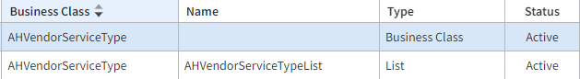

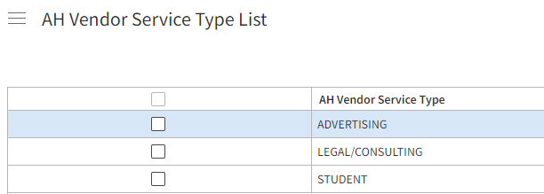

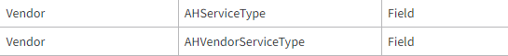

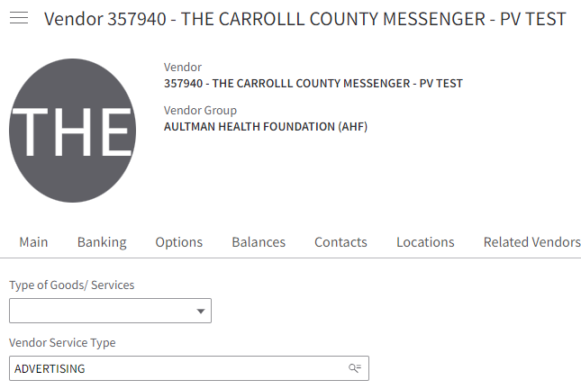

Vendor Import

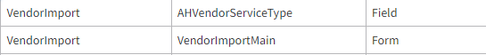

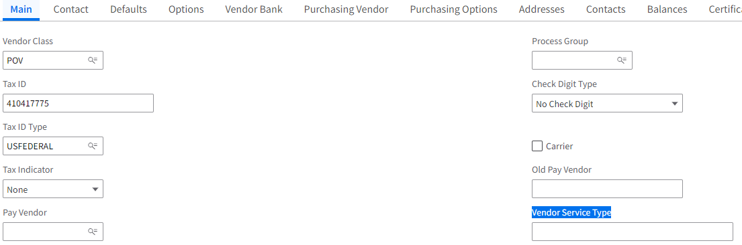

Technical Specifications

Solution Overview
<Describe high level proposed solution. Add components, trigger code, etc as applicable. If using Change Management, provide Tag ID to be used.>

The integration between Client to Infor comprises of the following steps:
- The source file will be placed on the sFTP Directory.
- The File Channel daemon will invoke the Infor Process Automation solution (IPA).
- The IPA will load the source file into the staging business class in FSM environment.
- The IPA will trigger the interface program to move the data from the staging business class to the solution business class when the source file has been imported successfully.
- The IPA will send notification of failure to identify recipients based on the following:
  - DBImport result
  - Interface program result
  - If there are unmatched GL strings vs the Cross Reference table
- A configured action can be triggered on-demand if the interface program failed.

Technical Configurations

Application Configuration

User Fields – Persistent
Business Class | Field Name | Default Label | Field Type | Field Rule/s | Definition
 |  |  |  | <Require, initial or default rules> | <High-level description of the field requirement>
Vendor | AHVendorServiceType | Vendor Service Type | Alpha, 30 | Optional

User Fields – Transient
Business Class | Field Name | Default Label | Field Type | Field Rule/s | Definition
 |  |  |  | <Require, initial or default rules> | <High-level description of the field requirement>

User Fields – Derived
Business Class | Field Name | Default Label | Field Type | Definition
 |  |  |  | <High-level description of the field requirement for ex. Return blank value>

User Fields – Condition
Business Class | Field Name | Default Label | Definition
 |  |  | <High-level description of the field requirement>

Configured Actions
Business Class | Action Name | Default Label | Definition
 |  |  | <High-level description of the action requirement ex. Add exit rule to update Cash Code based on the Cash Code Lookup table>

User Actions (New Action)
Business Class | Action Name | Based On | Action Type | Default Label | Definition
 |  |  |  |  | <High-level description of the action requirement ex. Trigger DPO Extract interface pflow for on-demand use case>

User Action Extensions
Business Class | Action Name | Based On | Default Label | Required Rule | Workflow | Definition
 |  |  |  |  |  | <High-level description of the action requirement>

User Request Actions
Business Class | Action Name | Action Type | Default Label | Required Rule | Workflow | Definition
 |  |  |  |  |  | <High-level description of the action requirement ex. Trigger DPO Extract interface pflow for on-demand use case>

User Relation
Business Class | Relation Name | Relation Type / To | Definition
 |  |  | <High-level description of the user relation requirement>

User Business Class
Business Class | Context | Key Field Definition | Implementations | Definition
 |  |  |  | <High-level description of the user business class requirement >
IN4ApprovalMatrix |  | Numeric, 5, autosequence |  | For FR 1.1

List
Business Class | List Name | Based On | Definition
 |  |  | <High-level description of the list requirement ex. Add columns>

Form
Business Class | Form Name | Based On | Definition
 |  |  | <High-level description of the form requirement ex Change form layout>

Page
Page Name | Based On | Definition
 |  | <High-level description of the page requirement >

Web Application & Menu
Name | Type | Definition
 | Menu, Web Application | <High-level description of the UI requirement >

File Channel
Configure a file channel to monitor for any incoming source files for processing. The process and error directory contents will be stored in the file storage. A single work unit will be created for each source file.
See Infor Landmark Technology Administration Guide and Infor Process Automation Administration Guide for CloudSuite for more detailed information on administration of file channels and receivers.

File Channel Setup
Channel Name
Description
Enabled
File Channel Type
Source File Directory
File Match Case Sensitivity
Error File Directory
In-progress File Directory
File Scan Interval in Minutes
SFTP Details | Refer to File Location section on this document.

File Receiver Setup
Channel Name
Receiver
Description
File Name
Ignore Delete Errors
ProcessFlow
Data
Startup Type

Process Flow Design

System Configuration Setting

<System Configuration Set>

Properties
Property Name | Description | Value

File Transfer Connection
Host
Protocol
User
Password
File System

<Process Flow Name>

Service Definition
Service
Service Is Enabled
Criteria 1
Criteria 2
Criteria 3
Proces Definition
Service Process Is Enabled

Trigger Variables
Variable | Data Type | Description | Initial Value

Schedule
Scheduled Action Name | Not applicable
Notify Recipient
Notification Type
Email Address
Execution Duration Notification
Email Address
Threshold Minutes
Scheduling Details
Schedule Type
First Time To Run
Latest Time To Run
Schedule Exlusion
Run Action Concurrently
Additional Details | <additional details such as frequency, dates, etc>
Action Failure Configuration
Strategy
Report Options
Threshold Minutes
Number of Retries
Continue On Failure To Run

ION Flow Design

Connection Point

<Connection Point Name>
Name
Description
Logical ID Type
Logical ID
Database Driver
Host Details
Schema Name
URL
User Details

Documents
Document Name | Receive in Application | Send from Application

NOTE: Attach screenshot of the connection point.

File Template

<File Template Name>
Name
Description
File Type
File Encoding
Format Type

Fields
Sequence | Field Name | Optional

NOTE: Attach screenshot of the file template.

<Document/work Flow Name>

Replication Set Design

<Set Name>
Replication Set
Maintain History Count
Description
Export
Enable Enterprise Search
Locale Set
Schema Output
Data Output
Include Replication As of Time Field

<Business Class>
Replication Set
BusinessClass
Delivered
Replicate Class
Disable Incremental Replication
Data to Extract
Condition

Fields
Field | Replicate Name | Resident | UserField | Type

Security Configuration

Security Class

<Security Class> (based on <Security Class>)
Component | Name | Rule
Business Class | <Business Class>
Field | <Business Class>.<Field>
Menu Item | <Menu>.<Menu Item>

Security Role

<Security Role> (based on <Security Role>)
Data Area | Assigned Security Class

Reports Configuration

<Report Name>

Column Mapping
<List of columns and their corresponding Business Class/Dimension/Measure/Attribute equivalent>

Selection Criteria
<Data filters>

Security
<Describe any security requirements or exceptions>

Parameters
<Specify parameters for user input>

Schedule
Scheduled Action Name | Not applicable
Notify Recipient
Notification Type
Email Address
Execution Duration Notification
Email Address
Threshold Minutes
Scheduling Details
Schedule Type
First Time To Run
Latest Time To Run
Schedule Exlusion
Run Action Concurrently
Additional Details | <additional details such as frequency, dates, etc>
Action Failure Configuration
Strategy
Report Options
Threshold Minutes
Number of Retries
Continue On Failure To Run

Output Format
<Specify the output format of the report, headers and footers, numbering format, font size>

Page Size
<Specify the page size of the report>

Drill Down
<Specify whether or not drill-down capabilities should be enabled and at what level>

Testing Process
NOTE: Applicable only if not using TES-060.

- <Requirement Definition Narrative>
Scenario | Expected Result
<Scenario Description> | <Expected result narrative>

- Cross Reference Table
Scenario | Expected Result
Create a record | User successfully created a record.
Delete a record | User should not be able to delete a record.

- Interface Delivery Method
Scenario | Expected Result
Valid file/s uploaded | - Header file picked up by File Channel for processing.  - IPA is triggered via File Channel (work unit generated).  - All related files are processed accordingly.  - Data is imported to correct staging business class/es.  - Data is interfaced to related solution business class/es.  - Source file/s are moved to processed directory.  - Import log/s are moved to processed directory.  - Email notification sent to specified recipient/s.
Invalid header file uploaded: incorrect file name | - Header file not picked up by File Channel.  - No work unit generated.
Invalid file/s uploaded: incorrect file header | - File is processed via IPA.  - No data imported to the staging business class.  - Successfully imported data for related staging business class/es are deleted.  - Inteface program is not triggered.  - Source file is moved to error directory.  - Import log is moved to error directory.  - Email notification sent to specified recipient/s.

- Error Handling
Scenario | Expected Result
<Scenario Description> | <Expected result narrative>

- Approver Notification
Scenario | Expected Result
Trasaction has been final approved. | Email notification sent to specified recipient.

Signature
NOTE: Applicable only if not using any approval trackers ex. IPON, JIRA.

By signing this document both Infor and <Client> agree and confirm their acceptance of information contained within this specification which encompasses detailed business processes, requirements, scope and solution design.

Functional Specification

Project Sponsor | Name | Position | Date | Signature
<Client> | Amy NeSmith | ERP System Support Analyst | 1.4.2024 | Amy NeSmith
Infor

Technical Specification

Project Sponsor | Name | Position | Date | Signature
<Client> | Amy NeSmith | ERP System Support Analyst | 1.4.2024 | Amy NeSmith
Infor

Appendix

Client Approval

Sample Vendor Files

LPL Codes

Process Flow

